Crab-eating Frog (*Fejervarya cancrivora)*

* Near fresh water, its diet consists largely of insects
* Environment with brackish water, small [crustaceans](https://en.wikipedia.org/wiki/Crustacean), including [crabs](https://en.wikipedia.org/wiki/Crab), form the main part

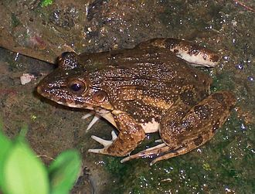

Where the river meets the sea <https://www.whoi.edu/oceanus/feature/where-the-rivers-meet-the-sea/>

What is Brackish Water? <https://thewatergeeks.com/what-is-brackish-water/>